**Cache Optimization for Machine Learning Models.**

Team Members: [Your Name], [Team Member 1], [Team Member 2]

**Project Description:**

The proposed project focus on explore and execute cache optimization techniques for improving the performance of machine learning models and other deep learning models. We will mainly focus on analysing the value of different caching methods or strategies—like Least Recently Used (LRU), Least Frequently Used (LFU), and Random Replacement policies in the context of model training and inference. By put on these caching strategies, we will analyse their impact and performance on the cache hit ratios and overall execution time during training the model on the dataset in this project we are using MNIST dataset to train the model.

**Motivation**:

As machine learning models and deep learning models become more complex and difficult to train them in a regular CPU, the requirement for efficient resource utilization and reduced latency in data access becomes primary task. Cache optimization provides a promising path to improve the speed and efficiency of model training by reducing the data retrieval times. This project idea not only offers practical learning with cache management methods but also helps to a deeper understanding of how these methods can be used in real-world machine learning situation. By analysing and matching the performance of distinct caching techniques like LRU,LFU and Random Replacement, our conclusion will be precious for developers looking to optimize their machine learning workflows, mainly in resource-constrained environments.

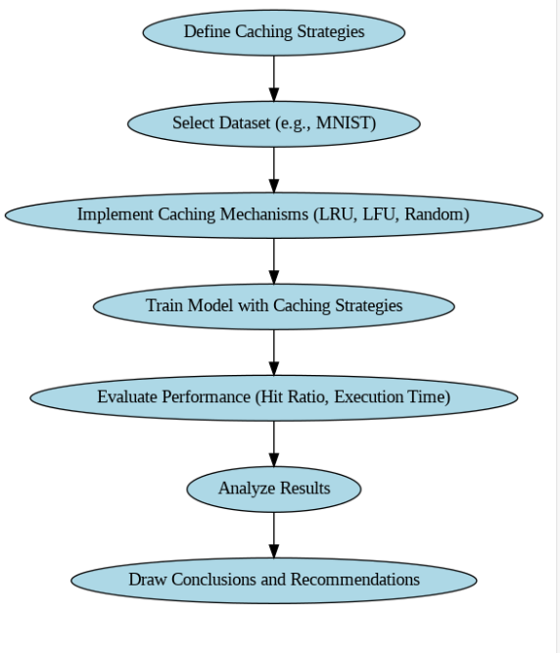

**FIGURE-1**